Julia Hotchkiss
Dr. Grove
ITEC 7460
Assignment 2
Thomas County Middle School Needs Assessment

After giving the Middle School Technology Use Survey to further understand how our teachers have adopted technology in the classroom and how we can improve, the technology team looked at the data hoping that it would be helpful in guiding our next steps. In the responses it was noted that there were not many suggestions on topics for further learning, but many stated that they used available technology readily with Google Apps, MobyMax, Prodigy Math, and Kahoot, etc.
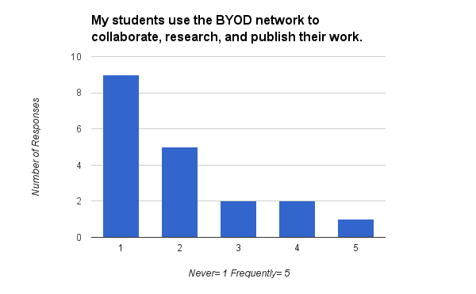
To further understand the teachers’ technology readiness, I used the LoTi Survey made from our PLC Group. My fifth grade teachers rated highest in technology being available in our school, and almost unanimously that they are not limited by computer lab availability. However, some discrepancies presented in areas, such as: lack of understanding technology; using devices for students to collaborate, research, and publish work; and allowing students to use their personal devices to complete work.
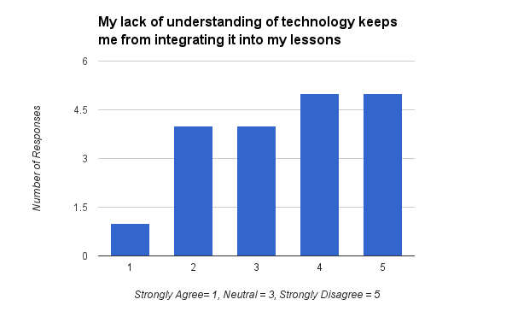
After reviewing the results from each survey, I interviewed a colleague, Mrs. Gail Trotter. Mrs. Trotter’s view on technology gave me insight to teachers’ thoughts and perceptions of technology in the classroom. Mrs. Trotter is a 17 year veteran teacher, who at times feels frustrated with technology. In review of the answers from the LoTi Survey, Mrs. Trotter said that she personally does feel like her lack of understanding of technology does keep her from integrating it into her lessons. During workshops, she said that instead of walking her through step-by-step on how to use a program, many times the presenter will provide examples of the program being used or resources. For instance, in a Google Classroom workshop, the presenter talked about inserting links in to the Classroom for students to access and gave out a list of helpful links, but did not show how to add a link. She disagrees that technology is limited at our school, which is consistent with other survey responses as shown below:
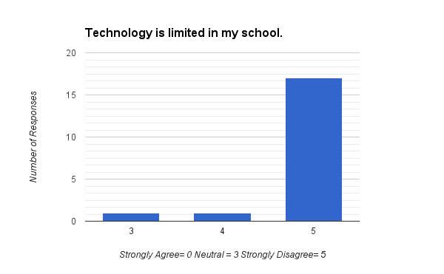
Mrs. Trotter answered that she was neutral on enjoying a student-led class because 5th graders have a hard time working by themselves. She also felt like the technical problems (Wifi, internet testing issues, etc) make it difficult because she doesn’t know how to help her students when there is a problem. As far as being able to allow students to guide their own learning and collaborate, research, and publish, she said that while she’d like to do those things, she doesn’t know how. Students in Mrs. Trotter’s class are invited to use technology to solve problems on their own because it “makes it more meaningful” to them, however personal devices are not required because every student has a Chromebook in each classroom. In conclusion, Mrs. Trotter would like for a coach to model how to use technology in the classroom effectively, especially using Google Classrooms.
The following goals and benchmarks are presented from the data of both assessments and interview with Mrs. Trotter:
Goal 1: Teachers are able to use Google Classroom effectively by integrating in to their class 1-2x per week.
Benchmark 1a: Teachers will set up a Google Classroom for each subject or class that they teach.
Benchmark 1b: Teachers will insert helpful links for daily or weekly assignments for easy access in to the Google Classroom Stream.
Benchmark 1c: Teachers will use Google Forms to conduct a simple formative assessment in the Google Classroom.
Goal 2: Teachers use Chromebooks to allow students to collaborate, research, and publish work (to site of their choice- blog, wiki, Google Classroom, etc.) at least once per grading period.
Benchmark 2a: Teachers will use Google Docs, Slides, and/or Forms to allow students to collaborate.
Benchmark 2b: Teachers will use site of their choice to encourage educational conversation as a foundation for publishing work.

Coaching Schedule
Date Topic Notes
10/14/16 | Google Classroom- roster
10/21/16 | Google Classroom- links/announcements
10/28/16 | Google Classroom- inserting Form/Doc/Slide
11/4/16 | Student Collaboration- sharing Doc/Slide

*This schedule is for planning purposes only. May be changed as needed and will continue throughout the year.

References
Hotchkiss, J. (2016). Middle School Technology Use Survey. Retrieved October, 2016, from https://goo.gl/forms/8wfRrgIrMEUkH5Jj1
Langford, W., Donahue, B., & Hotchkiss, J. (2016). LoTi Level Teacher Survey. Retrieved September 20, 2016, from https://goo.gl/forms/YtGn9cfwfHWkgeQq2

